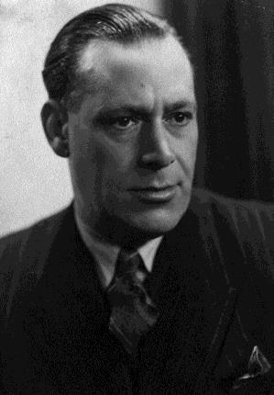
Stenenbrug 5
Léonard Salomon

A Loving Father
Léonard Salomon has a textile shop at the Grote Gracht, next to the butchery of Drielsma. He is divorced from his non-Jewish wife and lives with aunt, Carolina Haguenauer-Karels, at the Stenenbrug. His son Emile grows up at the Drielsma family, while his other son, Jackie, lives with their mother (and Léonard’s former wife), Rosalie Karels. Léonard Salomon often visits the Isaack family, which owns a leather shop on the same street (Grote Gracht).
It is likely that Léonard has been active in the resistance and has spread illegal opposition papers. On suspicion of these acts, the Germans forbid him to trade in textiles any longer.

Betrayed by the NSB
Together with the Isaack family, Léonard is arrested for the first time in August 1942. They have to report at a school at the Professor Pieter Willemsstraat and are then brought to the transit camp of Westerbork. One month later, Léonard is released in order to make sure that his half-Jewish children can be left behind properly – a rare privilege which he owes to his mixed marriage. On November 11, 1942, he is arrested for the second time.
Today, it is believed that he spent some time in a Maastricht prison. A member of the NSB (the Dutch Nazi party) who lived in the Ridderstraat probably betrayed him. Son Emile saw his father until just before he was arrested for the second time. When wondering about how it could get as far, Emile presumes that his father never went into hiding because he could never afford to do so.

Murdered in Sobibor
After his second arrest, Léonard spends nearly 7 months in camp Westerbork. On May 3, 1943, he hears that he will be transported to the East. In the night that follows, he cannot sleep. He writes a moving letter to his sons Emile and Jackie: ”Now everything is over en I will leave for an unknown world, in which I will not hear from you again.” Just before the transport to Sobibor leaves, he is able to throw the postcard out of the train for Emile and Jackie: “I hope the best for you, I will keep courage and always think of you, your father will always be with you in your hearts.” Léonard arrives in Sobibor on May 7 and is murdered on the same day.

